1. **Create a simple project with Jenkins connected to your GitHub repository:**

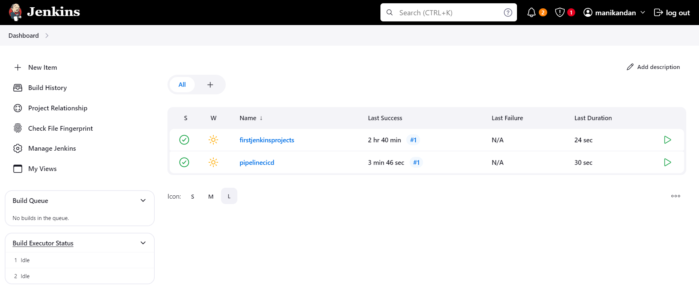

1. **Pipelinecicd project:**

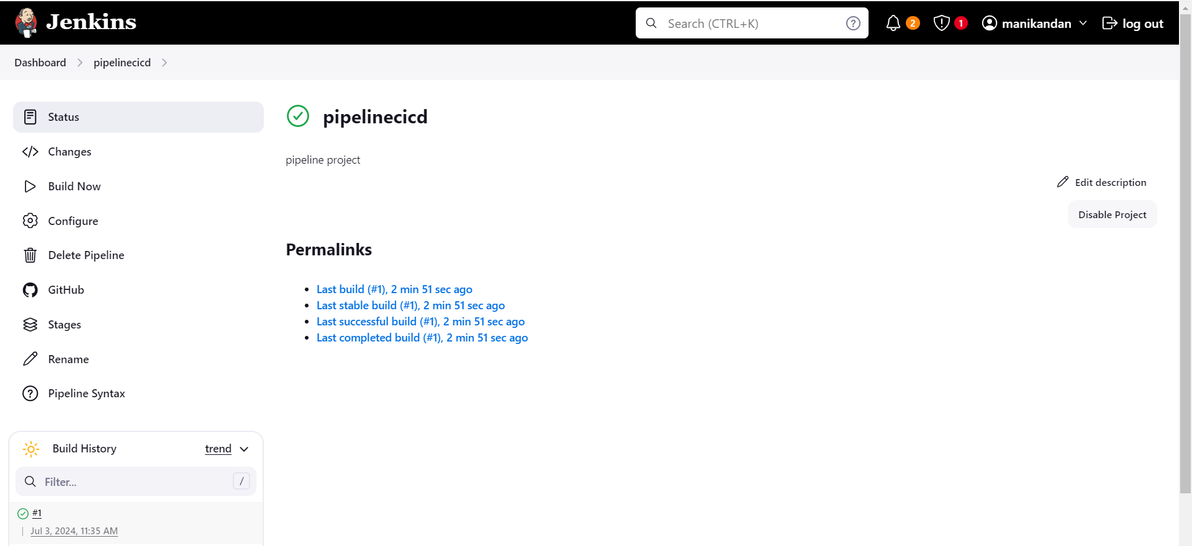

1. **Github repository:**

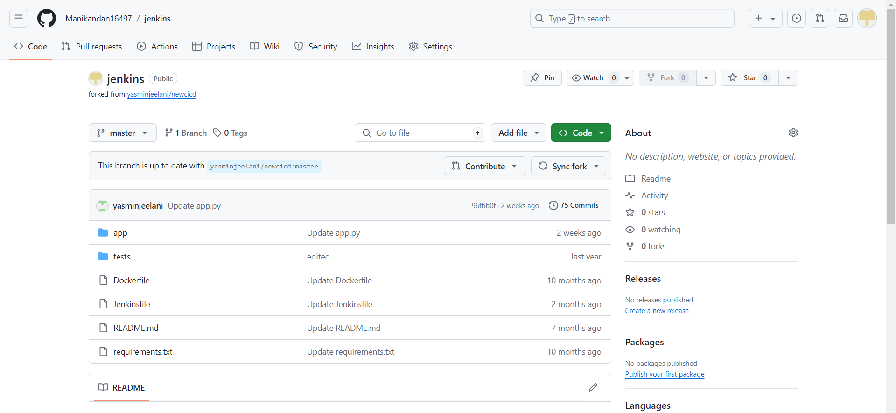

1. **Console output:**

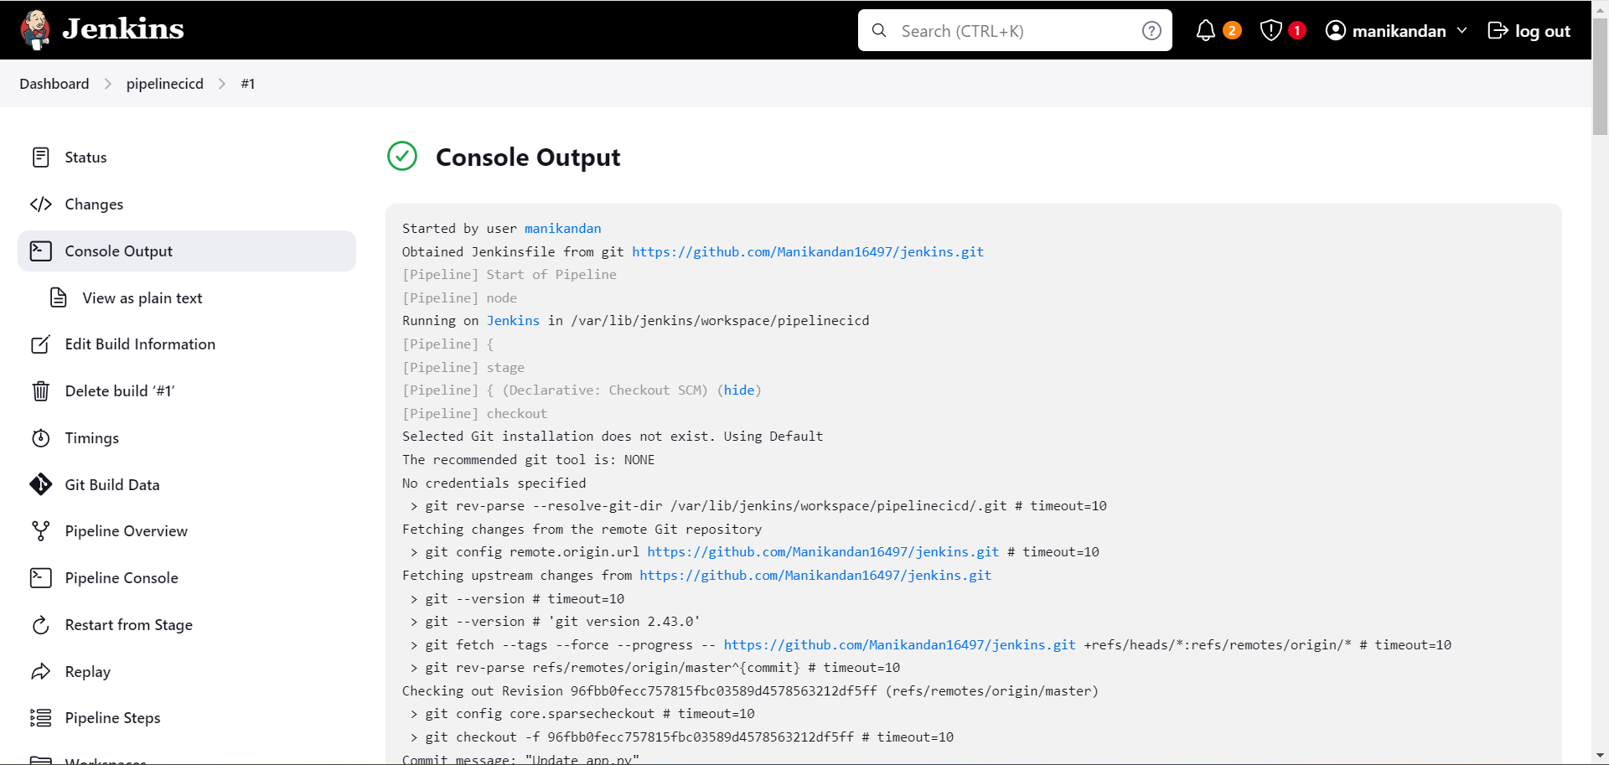

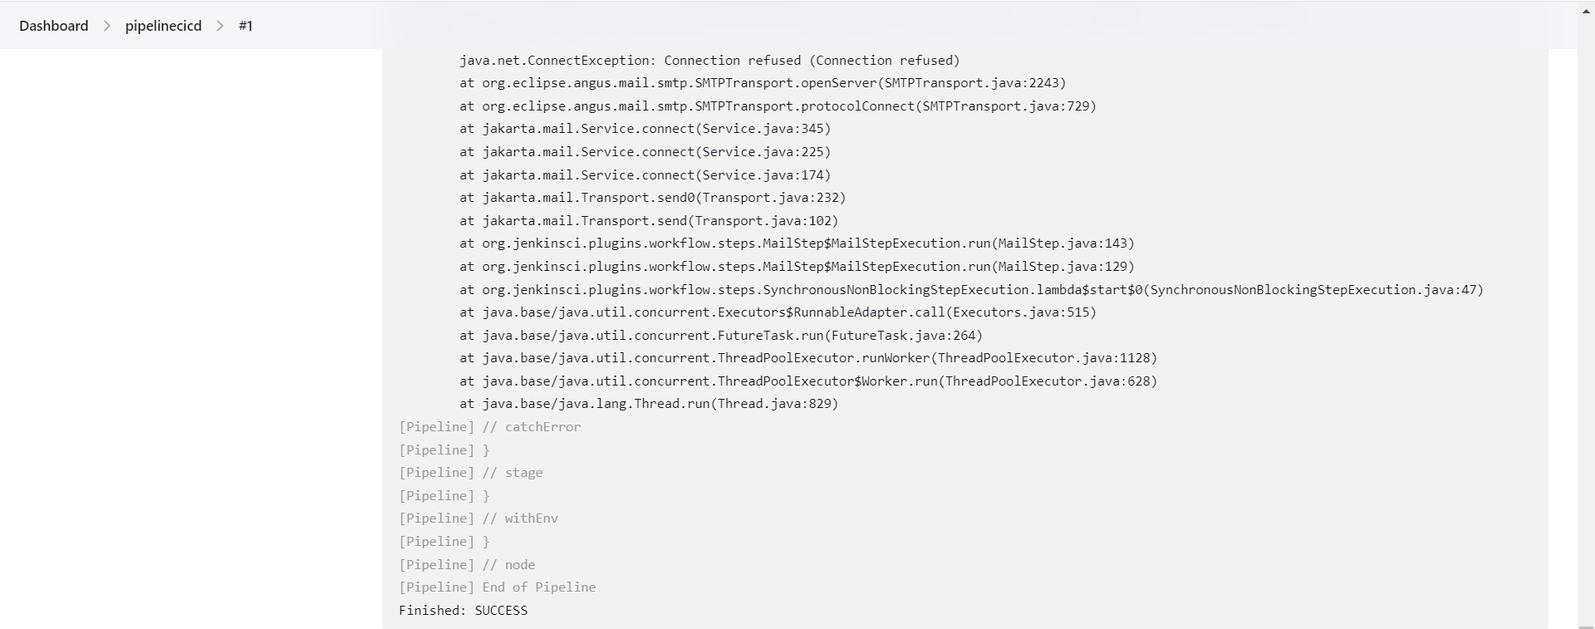

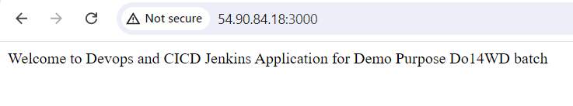

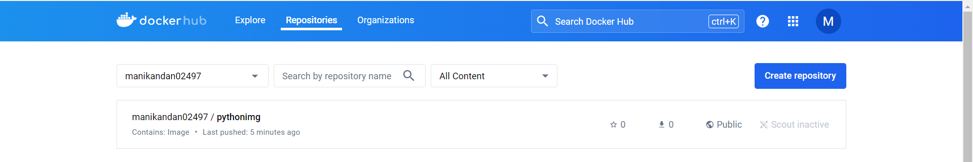

1. **Configure the mail in jenkins:**

**This is the test mail from Jenkins:**

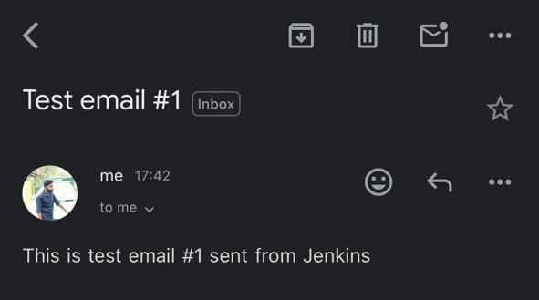

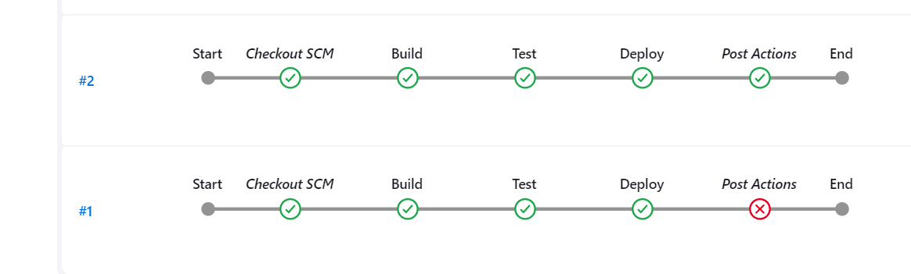

1. **When a commit is made to your repo, automatically build must get triggered from Jenkins:**

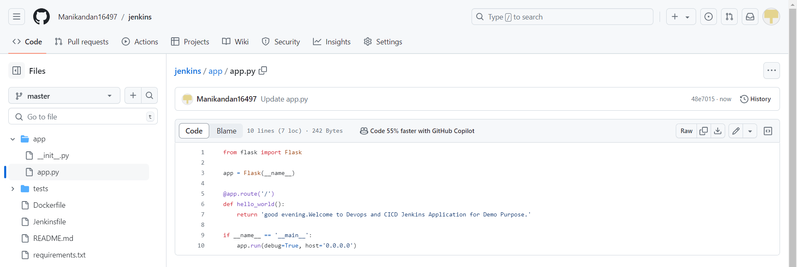

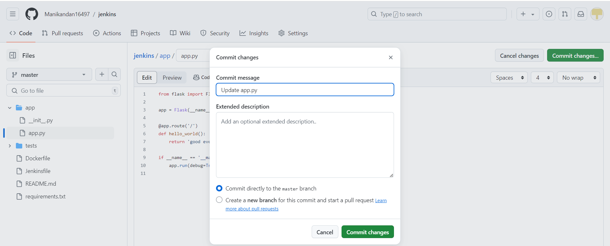

1. **The output must be shared via email:**

